# Softuniada 2019

## Nexus

While studying arrays of various atoms, Doctor Sanity managed to discover a strange behaviour – while connecting 2 pairs of atoms from 2 parallel arrays, a nexus is initiated. If the 2 connections cross each other, the nexus disperses and loads all other atoms with nuclear value. He wanted to create an algorithm simulating this behaviour, but he’s too lazy… So you’ll have to write it for him.

You will receive **2 sequences** of **integers**, separated by **spaces** – the **2 arrays** of atoms.

After that you will start receiving **2 pairs** of **indices** – the **2 connections** in the **arrays**. Each connection will be in the **form** of an **index** from the **first array** and another **index** from the **second array**.

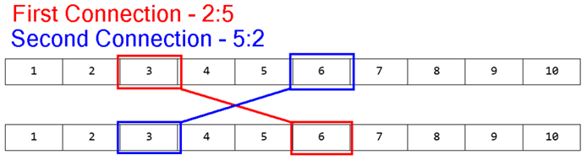

You must check if the 2 connections **cross** **each other**. If they **do**, you must **remove** **all elements** **between** them from **both arrays**, and you must **increase** **all integers**, that are **left afterwards** in **both arrays**, with the **summed** **up** **value** of the **connected elements** (**Nexus value**).

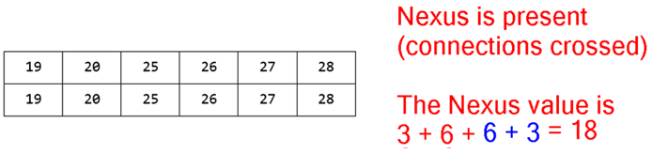

In case of **no crossing** of **connections**, you should **do nothing**.

You will continue receiving connections until you receive the command "nexus", at which point you must **print** what is **left** of the **arrays** and end the program.

### Input

The input consists of several sequences:

* First you will receive **2 lines**, containing **sequences** of **integers**, separated by **spaces** – the arrays.
* On the next **several lines** you will receive the **pairs** of **connections** in the following format:  
  {firstArrayIndex}:{secondArrayIndex}|{firstArrayIndex}:{secondArrayIndex}
* When you receive the command "nexus" the input must end.

### Output

The output should consist of **2 lines**, containing what is left of the **arrays**, with its elements – **separated** by each other with a **comma** and a **space**.

### Constraints

* The input will always be in valid format.
* The arrays will contain integers in **range** **[0, 10000]**.
* The arrays will **not necessarily** have the **same length**.
* The **indices** in the **connections** will always be **valid** and **inside** the arrays.
* Allowed time / memory: 100ms / 16MB.

### Examples

|  |  |  |
| --- | --- | --- |
| ****Input**** | ****Output**** | ****Comment**** |
| **1 2 3 4 5 6 7 8 9 10**  **1 2 3 4 5 6 7 8 9 10**  **2:5|5:2**  **nexus** | **19, 20, 25, 26, 27, 28**  **19, 20, 25, 26, 27, 28** | See the examples above. |
| **5 10 15 20 25 30**  **40 35 30 25 20 15 10 5**  **1:6|2:1**  **nexus** | **75, 90, 95, 100**  **110, 75** | The range of the elements in the second array is larger than that of the first array.  Naturally, more elements are removed from the second array. |
| **9 5 10 4 5 6 7 10**  **3 3 3 4 5 6 7 8**  **0:1|1:0**  **0:1|1:0**  **0:1|1:0**  **nexus** | **634, 637**  **634, 635** |